TITLE

A THESIS SUBMITTED TO THE GRADUATE DIVISION OF THE
UNIVERSITY OF HAWAI‘I AT MĀNOA IN PARTIAL FULFILLMENT
OF THE REQUIREMENTS FOR THE DEGREE OF

MASTER OF SCIENCE
IN
DISCIPLINE

GRADUATION DATE
By
Name

Thesis Committee:

Keywords:

© NAME

Acknowledgements
Use Pre TOC style of title for any section BEFORE the Table of Content (TOC)
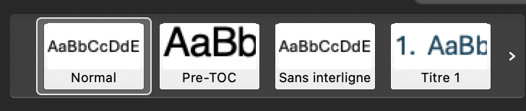

Dedications

Abstract

Table of Content
go to :
References
Table of Content
Formel Style (can change but it works well for me)

List of Figures
Figure 1- Example 7

Go to:
References
Insert table of illustrations
Legend : Figure

List of Tables

Table 1- Example 8

Go to:
References
Insert table of illustrations
Legend : Table

Section 1 – USE TITLE 1 STYLE
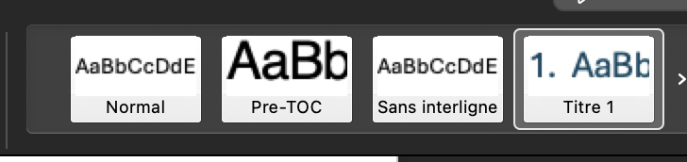

Subsection 1.1 - USE TITLE 2 STYLE

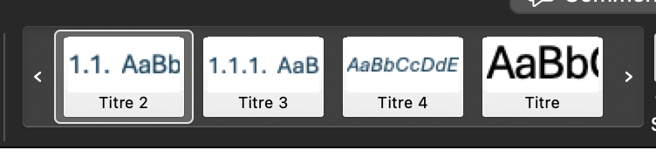

Subsection 1.1.1 – USE TITLE 3 STYLE



I dont have other subsections set up so if you need more levels of subsection you need to set them up yourself for them to show up in the TOC.

Section 2

Sub 2.1

Sub 2.1.1

Section 3

Sub 3.1

Sub 3.1.1

Section 4

Sub 4.1

Sub 4.1.1

Section 5

Sub 5.1

Sub 5.1.1

References

Supplemental Material

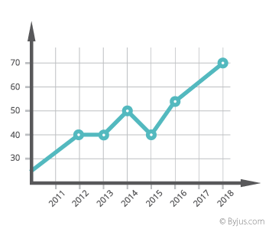
Figure 1- Example
Click on the Figure
Use the Refereneces
Insert a Caption
Add Caption
Make sure it says “TEXT: Figure”
Position : Below the figure

Table 1- Example
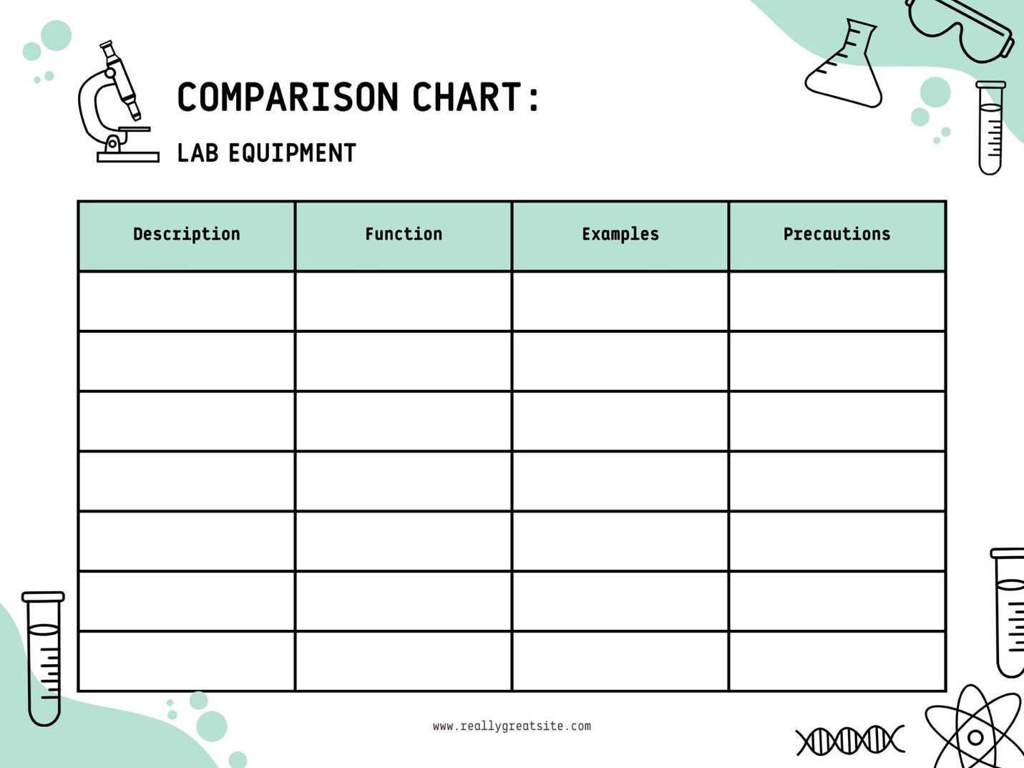

Click on the Figure
Use the Refereneces
Insert a Caption
Add Caption
Make sure it says “TEXT: Table”
Position : Above the figure

